Statement of Purpose
BREAKAWAY: 1183479

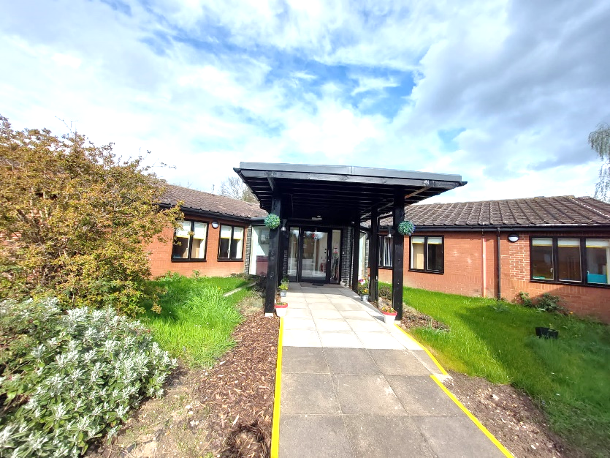

This document fulfils the requirements of the Children’s Homes (England) Regulations 2015 Schedule 1, the Department for Education Guide to the Children’s Homes Regulations including the quality standards April 2015 and the Social Care Common Inspection Framework April 2017.

TABLE OF CONTENTS
- INTRODUCTION

- QUALITY AND PURPOSE OF CARE
- Statement of the range of needs
- Aim and Ethos of the home
- Accommodation offered
- Location of the home
- Arrangements for supporting the cultural, linguistic and religious needs of children
- Complaints
- Access to the home’s child protection and behaviour management policies

- VIEW’S WISHES AND FEELINGS
- Consulting with Children
- The home’s policy and approach to anti discriminatory practice and children’s rights

- EDUCATION
- Supporting children with special educational needs
- Supporting education and educational achievements

- ENJOYMENT AND ACHIEVEMENT
- Activities within the home

- HEALTH
- Health care provided within the home

- POSITIVE RELATIONSHIPS
- Promoting contact between children, families and friends

- PROTECTION OF CHILDREN
- Home approach to monitoring and surveillance
- Behavioural support

- LEADERSHIP AND MANAGEMENT
- Manager and Responsible Individuals’ details
- Support workers experience and qualifications
- Staffing structure
- Promoting appropriate role models within the home
- CARE PLANNING
- Admission to the home

1. INTRODUCTION
1.1 The statement of purpose is a requirement of the Children’s Homes (England) Regulations, April 2015.
1.2 It is not a brochure, it is a manual that is used by all those who have an interest in the service. It performs a task for those internal and external to the home.
1.3 It connects the needs of the child with the aims and objectives of the setting. It connects the home’s definition of good practice and the clear objectives through which that practice can be achieved. It connects policy with practice. It connects the quality and range of services provided.
1.4 The statement of purpose is formally reviewed annually and approved by Slough Children First (SCF) Executive Leadership Team on an annual basis.
1.5 There is a more accessible guide for children
2. QUALITY AND PURPOSE OF CARE
Statement of the range of needs:
2.1 Breakaway is a short break Children’s home, providing respite care for children who have complex needs, a learning and/or physical disability. The children who access Breakaway may require personal care, medication, additional health care, behavioural support and support with learning and achievements.
Aim and Ethos of the home:
2.2 Great and aspirational care is taken of the children who attend Breakaway. The service adopts an approach which is child centred and supports collaboration with all.
2.3 Breakaway plays an active part in delivering Slough Children First Vision
“…every child in Slough should be Safe, Secure and Successful”.
We are here to:
- Protect you from harm
- Help you to get support so that you can be physically and emotionally healthy
- Work with you and your community to help you to be independent and resilient
We’ll do this by:
- Integrating services with partners
- Providing information & choice
- Focusing on what is most important
- Focusing on quality practice

2.4 Breakaway achieves this by ensuring children have the opportunity to participate in a range of activities and positive experiences, which promote their development, whilst delivering sustainable support to the whole family. We believe that every child is an individual with the right to enjoy life within the community, appropriate to his or her age. Breakaway advocate respect, dignity and freedom of choice for all, working with future in mind.
2.5 We create a positive environment which promotes a ‘friendship matters’ culture, and where children are offered experiences and opportunities to assist them with achieving their aspirations and goals in life.
Accommodation offered:
2.6 Breakaway is registered with Ofsted and has six bedrooms meaning that a maximum of six children; male, female or gender neutral from 6 years of age up to their 18th birthday, can stay overnight, alongside those children who attend for tea visits. We ensure individuals have a choice of bedding and will purchase preferences to make them feel welcomed and valued.
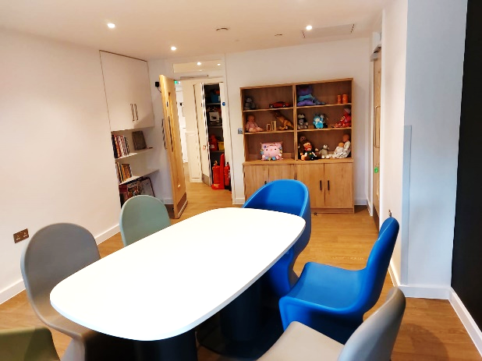
The accommodation is all on the ground floor with all areas accessible to people with mobility difficulties including wheelchair users. Breakaway has undergone a full refurbishment with additional lobby and lounge areas on both sides of the building for children to enjoy.
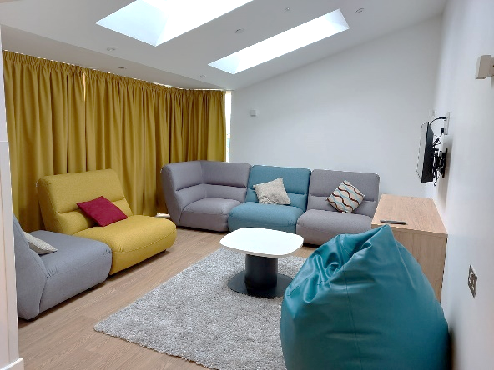
2.7 Internal facilities include fixed and mobile hoisting equipment, sensory room, activities hub, porch for handovers and fully spacious accessible garden which includes birds nest, climbing frame, sand pit and other play equipment.

2.8 The lounge and playrooms areas are light and spacious and contain a wide range of toys and activities for the children to access, maximising their opportunities to learn through play. There are two new extended lounge areas which incorporate activity hub and gaming room for children to have quality time whilst accessing the service.
Location of Breakaway:
2.9 Breakaway is based in Slough, Berkshire and is situated in a quiet residential area close to the town centre, local leisure resources, and two local parks. The location of the home has been formally assessed and there are no known significant risks with regard to location. There is ample parking close by, and the train station is within walking distance.

Arrangements for supporting the cultural, linguistic and religious needs of children:
2.10 The work done in advance of a child starting to stay at Breakaway is designed to ensure that everyone working with the child has the necessary information about a child including their communication, cultural and religious needs and how those will be met.
2.11 Breakaway is inclusive and responsive to the individual needs and aspirations of children and their families. We also aim to be family orientated, culturally competent, and respectful of children who have a diverse range of needs and backgrounds. All the children who receive a service from Breakaway are valued as individuals, with different needs and individual rights.
2.12 The values deriving from different backgrounds are recognised and respected at all times. Within the care planning process and the completion of the “This is me” document, the team recognise different needs in relation to ethnicity, culture, religion, diet, gender identity and sexual orientation where they may exist.
2.13 Breakaway has a number of resources which recognise ethnic, cultural and linguistic differences, and support workers enable the children to explore these through play. They include books, posters, toy figures, games, multi-cultural music and cultural events. Support workers encourage children to question and celebrate differences through activities, role modelling and discussions.
2.14 Being part of SCF, Breakaway has access to services that can provide translation of documents into other languages, braille and audio, and interpreters to attend reviews or meetings where necessary.
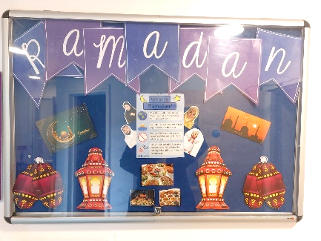
2.15 Special dietary needs and individual preferences are recognised and are included in the menu planning process and the child’s individual care plan.
2.16 Breakaway celebrates special times of the year e.g. Eid, Christmas, Easter, St Patrick’s Day etc. to help us understand all religions and cultures. We also make a special effort to celebrate children’s birthdays. If a child wishes to participate in any religious activities or observance, we will make arrangements within the home e.g. a quiet place to pray or read/ listen and support them with this.
2.17 Staff who work at Breakaway have knowledge of Makaton and PECS to assist communication with the child. If the child is able to communicate verbally, support workers will listen and act upon what they say. Social stories and picture boards and iPads are also helpful ways for us to communicate with children and are used as necessary to facilitate communication for those who are non-verbal.
Arrangements for dealing with complaints:
2.18 We encourage children and their families to be open and honest about any concerns or worries they have, and we listen and act upon any concerns promptly.
2.19 Complaints are responded to at the earliest opportunity and by the most appropriate person in accordance with SCF’s complaints procedure, copies of which are available on request at Breakaway, or on the SCF website.
2.20 Within Breakaway we have developed various ways in which children can make formal and informal comments, observations, or complaints. These include;
- An accessible Children’s Guide found at the entrance to the home, which includes information on how to make a complaint and where to find support in doing so.
- A range of tools such as symbols accessible in the home to ensure varying levels of communication are catered for.
- A child’s consultation form, which children are supported to complete before their reviews.
- Children are also visited regularly by their Social Workers which offers a further independent opportunity to feedback with regards to the service they receive.
- Visits from an independent Advocate
- Key-work/ 1:1 sessions, affording opportunities to communicate with the use of picture exchange communication systems (PECS), pictures.
- Support workers to record any observations they might make of non-verbal children communicating or expressing unhappiness or worries, in recognition of the significant difficulty these children have in making a complaint.
2.21 Breakaway is committed to receiving and acting upon feedback from service users, whether this is positive or indicating dissatisfaction with the services provided. Complaints and compliments are monitored by the Regulation 44 Independent Visitor each month.
Children and their families are also able to make a complaint to Ofsted or to the Children’s Commissioner for England, Dame Rachel De Souza at: Office of the Children’s Commissioner 0800 528 0731
advice.team@childrenscommissioner.gsi.gov.uk
Or
Ofsted
Piccadilly Gate Store Street Manchester M1 2WD Tel : 0300 1231231
enquiries@ofsted.gov.uk
And or Slough Children First Complaints Manager:
ragena.khan@sloughchildrenfirst.co.uk Tel: 01753 875825
Access to the home’s child protection and behaviour management policies
2.23 Breakaway adheres to the Berkshire LSCB Child Protection Procedures, a ‘live’ online document which can be found at: http://proceduresonline.com/berks/
2.24 Alongside this Breakaway also has an approved bespoke safeguarding policy, which includes an easy to follow flow chart. This policy is available to support workers as a paper document in the policies and procedures folder, on a shared computer drive and available to children, families, carers, professionals and others involved in the care and protection of a child upon request.
2.25 Breakaway also has a Behaviour Management Policy, available in the above formats and upon request.
Young people have individual behaviour management plans as part of their key documents.
3. VIEWS, WISHES AND FEELINGS
Consulting with Children
3.1 Regular consultation takes place with children regarding their experience of Breakaway and how they would like the service to develop. Breakaway recognises that children should be offered opportunities, choice and control at every appropriate opportunity.
3.2 Consultation is part of our everyday work however the below illustrates some of the other methods we use:
- Breakaway children meetings which provide feedback to the support workers and management team about the unit on a monthly basis.
- Choices in the meals provided
- Structured / direct observations from support workers
- Analysis of behavioural incidents
- Feedback from parents/carers and other involved professionals
- All children have a key worker, who's role it is to get to know them especially well and advocate for them/ help them to advocate for themselves where needed.

Breakaway’s policy and approach to anti discriminatory practice and children’s rights
3.3 Breakaway creates a climate that is committed to equal opportunities, inclusion and challenging barriers and discrimination. We work within the Equality Act 2010 which sits alongside the requirements in the Children and Families Act 2014 and the Special Educational Needs and Disability Code of Practice.
- All Breakaway staff are ‘signed up to’ SCF Vision and Values and we adopt these values and behaviours which form part of annual performance appraisals
- Breakaway recognises that all people are unique and have a contribution to make for the benefit of all.
- Staff understand that discrimination arising from disability is treating a disabled child unfavourably because of something arising in consequence of their disability, and work to ensure that children in their care are protected from any such experiences.

3.4 The protected characteristics as below are understood, and reasonable adjustments made as necessary to break down barriers for inclusion.
- Age
- Disability
- Gender reassignment
- Marriage and civil partnership
- Pregnancy and maternity
- Race
- Religion or belief
- Sex
- Sexual orientation
Breakaway has a policy on anti-discriminatory practice that all staff adheres to. No child or groups of children or their families will be discriminated against. Our support staff will not judge or treat children at Breakaway or their family unfairly or unequally
3.5 Should support workers become aware that an individual or a family is experiencing discrimination they will offer immediate support and promptly address the needs of all concerned. This will then be passed on to the Unit Manager to address as necessary
3.6 Anti-discriminatory measures in place to protect children and their families include:
- Careful observation and monitoring
- Accurate case recording
- Being vigilant in the key worker role
- Having an understanding of the families’ needs
- Raising concerns with others
- Whistle blowing policy
- Breakaway Advocate

3.7 Slough Children First and Breakaway are committed to the principles of The Human Rights Act 1998. Children with disabilities are vulnerable. Their needs and interests must be heard and given the utmost consideration in decision making. Breakaway use every opportunity to promote the rights of children with disabilities and to improve children’s lives and social status.
3.8 Within the principle of equal opportunities, all children have rights. At Breakaway children have the right to:
- Be treated with respect
- Be treated fairly
- Be listened to when people are making plans about their future
- Be able to go to school
- Be in good health
- Be able to complain if they are unhappy or worried about something
- Be able to have an advocate who can advise and help sort out matters when their stay is not going well
- Be looked after by support workers who actively promote the above rights

4. EDUCATION
Supporting children with special educational needs
4.1 Children during their stay at Breakaway continue to attend school as part of their daily routine. School transport will be consistent with the child’s home to school arrangement to ensure continuity. Collaboration takes place between the Transport department and Breakaway staff to ensure that any communication from school to home or transport is fluid.
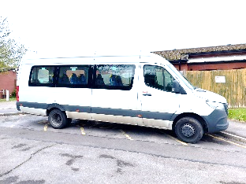
4.2 Staff at Breakaway currently transport children to and from Arbour Vale School. Children accessing other schools are transported by their parents/carers.
4.3 Where it is helpful or requested some children have a home/ school/ Breakaway diary to help ensure a consistency of communication between all carers/settings. This enables support workers to gain an insight into the child’s day and help to reinforce praise events and achievements that day/week or share worries/concerns. There is always close collaboration between Breakaway, families, school and the Children with Disabilities team.
4.4 The importance of education is acknowledged. If children bring homework into the unit to complete, support workers assist with this where necessary, and they are encouraged to complete tasks. There is a wide range of books available in the unit, iPads, a desk top computer with a wide range of applications, games, toys, art activities, and opportunities to access activities which support their learning and their development of independence skills, such as shopping and cooking.
Supporting education and educational achievements
4.5 Breakaway staff attend school reviews and make visits to the schools to see their key children. The key worker will maintain good contact and work together with the teacher and child to plan their smart star achievements in line with those educational targets set at school. There is an achievement rewards system at Breakaway in which children can choose a star or certificate when they have reached or made good progress in working towards their smart stars. We also recognise and celebrate achievements through the use of our ‘WOW’ board which is displayed in the hallway.
The Unit Manager meets termly with a designated member of the school staff to identify areas of concern or improvement with either individual children or services, and attends the professional meetings held at Arbour Vale School when required.
5. ENJOYMENT AND ACHIEVEMENT
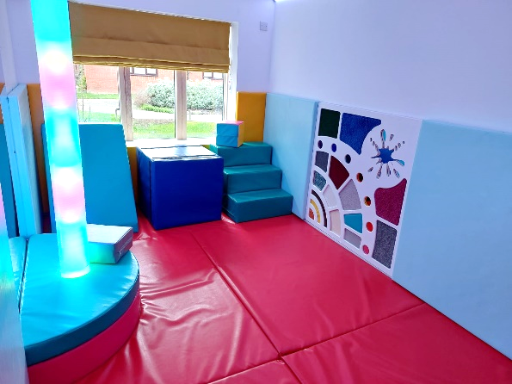
Activities within the home include
5.1 We provide an extensive variety of activities which take into account a child’s individual likes, choices, needs and aspirations. The provision of play equipment and outings is a key aspect of the service. A wide range of play activities are provided, these include, up to date I.T systems (tablets), art, games, puzzles, sensory toys. A newly refurbished sensory room is accessible to all children.
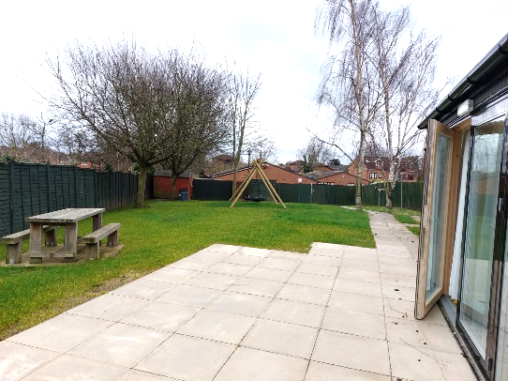
5.2 A safe and secure garden which provides opportunities for enjoyment with specialist outdoor play equipment such as, water play, bird’s nest swing, sand pit, water play and climbing frame with slide.
5.3 Access to a minibus and drivers, which are used to provide a variety of outings such as trips to the coast, local parks and enable the children to access local community facilities.
5.4 A child can be assessed to have the opportunity to access and enjoy the local community either alone or with their peers with appropriate support. This is particularly valuable to children approaching adulthood.
5.5 Key work/ 1:1 sessions, that promote independence e.g. cooking session. This involves decision making, teamwork, shopping for ingredients, preparing and cooking the main meal for the evening, and eating together.
6. HEALTH
Health care provided within the home
6.1 Breakaway supports children with a range of health needs. These include epilepsy, asthma, eczema and on feeding plans. Supporting individual children’s health is covered within the child’s care plan, and emergency procedures are in place where necessary. Where nursing care is required, we liaise with our health partners to ensure this service is commissioned.
6.2 As part of thinking future and reducing dependency, children are encouraged to take an interest in, and as far as practical be responsible for their own health and that of others. We will aim to support children to be as independent as possible with all areas of their care and be healthy individuals
6.3 The local community nursing team deliver specific care plan training for the Breakaway team in the administration emergency epilepsy/ anaphylaxis medication, water flushes and procedures as well as competencies for special feeds. Providing continuity, the nurses delivering this training are usually the named specialist nurse for the child. The health care plans are located in individual care plans. Support workers training sheets are in training file in the office.
6.4 Children are always listened to which ensures that support workers are aware of and can address any ailments or an emotional need causing concern.
6.5 Breakaway has access to the Occupational Therapist within the Children’s Specialist Support Team who provides support in meeting the needs of children requiring manual handling and specialist equipment.
6.6 The unit is able to provide a service for and assist children who are prescribed medication, for which there is a ‘Breakaway Safe Administration of Children’s Medication Policy and Practice Guidance’. Children who have complex health needs are able to access the service with prior agreement of the Primary Care Trust. It is the responsibility of the SCF and the home manager to ensure a trained and competent staff member is available to support that child whilst in the unit. Support workers are all aware of the need to promote healthy living, and actively assist children in daily hygiene routines, dental care, food and menu choices. Health is also explored through play, stories and activities.
6.7 Breakaway carries out a constant cleaning programme to prevent infection, liaison with external agencies re infectious diseases and protocols to manage these are written and followed.
7. POSITIVE RELATIONSHIPS
Promoting contact between children, families and friends
7.1 Breakaway is a Short Break Unit; therefore the aim is to provide children with enjoyable respite /short breaks whilst also giving their families a break – this in itself assists with family relationships and resilience and supports permanency for children within their own families.
7.2 Breakaway operates an “open door” visiting policy, and, subject to any legal orders, contact or visits can be made with a child at any time during their stay. As many of our activities include outings outside of Breakaway, parents and carers are advised to call / check beforehand if they are intending to visit, in order to ensure the child is at Breakaway at the time of any planned visit.
7.3 Children are able to telephone their families at any time. In certain circumstances the frequency and duration may be specifically outlined in their individual care plans. Support workers will be aware of each individual’s level of support needed as outlined in their care plan and will support as necessary.
8. PROTECTION OF CHILDREN
Homes approach to monitoring and surveillance
8.1 Breakaway has no sophisticated or recordable form of surveillance of the children. For children with health needs that require a higher level of monitoring then an audio monitor or bed alarm for example can be used i.e. if a child has nocturnal epilepsy. Such devices are only used when this is identified as a need in the care plan and prior agreement is sought from parents/carers, wherever possible the child and the placing authority. To ensure maximum privacy the child is made aware when the monitor is switched on and off each time using words, Makaton or symbols as appropriate for them.
8.2 In accordance with need, children staying at Breakaway are provided with support that includes a level of supervision based on their assessed individual needs, as identified in their need’s profiles on ratios such as group, 1:1, or 2:1.
Breakaway is designed so that children can have access to all shared areas of the home, enabling independence and privacy where safe to do so.
8.3 Breakaway has key lock door system on all external doors and keypad exit systems on all internal doors apart from the communal areas, toilet and bathroom doors. There is unrestricted access to the garden / play area.
8.4 The external front access key lock door is not to restrict children from leaving, but to ensure they are safe in doing so. Children have a variety of communication methods available to them to be able to ask a member of staff if they want to go on an outside activity or to be picked up by a parent/carer. These identified risks are reflected in the building risk assessment.
8.5 Breakaway support workers are aware of the procedures and protocols in place with regard to children who go missing and who may be at risk of child sexual or criminal exploitation. A location risk assessment has been undertaken and there are no known risks associated with the location of the unit.
Behavioural support
8.6 Breakaway operates within the Slough Children First Behaviour management policy statement and Guidance. All Breakaway staff receives training (Team Teach) every two years. The children’s care plans/risk profiles are updated annually (or before if anything changes), with multi-agency input, and are agreed and signed off by parents/carers.
8.7 A multi-agency approach is always used to support behavioural needs in partnership with families, and the Behaviour Support Specialist, to identify the most appropriate and helpful ways to support children with a range of emotions and behaviours, and to ensure behaviour management responses are consistent across settings.
Team Teach Aims:
- To promote the least intrusive positive handling strategy and a continuum of gradual and graded techniques, with an emphasis and preference for the use of verbal, non-verbal de-escalation strategies being used and exhausted before positive handling strategies are utilised.
- To enable services to develop acceptable and authorised responses to disruptive, disturbing, angry and aggressive behaviours in a manner that maintains positive relationships and provides safety for all, by training in Team-Teach.
- To reduce the number of serious incidents involving physical controls in all settings and to emphasise the importance of exhausting behaviour management strategies in the first instance.
- To increase the awareness of staff concerning the importance of recording and reporting, monitoring and evaluating, all incidents involving positive handling.
- To provide a process of repair and reflection for both staff and children.

8.8 Policy and practice is about diverting the children from behaviour that is unacceptable, using methods agreed in individual care plans and risk profiles, focusing on positive reinforcement, modelling appropriate behaviour and redirection/distraction strategies.
8.9 At all times workers are mindful of the need to ensure that the behaviour of one child does not harm another. A distressed child may be supported by withdrawing them from the group to enable a time for calming down.
8.10 Should any child need any type of physical support / intervention it is recorded in the Restraints book, and on their electronic file which alerts their social worker. Parents/carers are notified as soon as practicable and appropriate. Support workers are required to record the child’s response/ views in the intervention log, and any impact explored.
8.11 Distraction and prevention is a successful skill of the team. The use of restraint at Breakaway is very rare and detailed records are monitored by the Home manager at Breakaway, and through the monthly Regulation 44 visits and by the Registered Responsible Individual (Head of Service).
8.12 We promote positive behaviour, and our aim is to assist children in restorative conciliatory responses when undesirable behaviours occur. Again rarely, it may be appropriate to use a sanction. A child should be given a warning of an impending sanction and opportunity to alter their behaviour. Sanctions will only be used where it has been clearly identified and agreed in an individual’s care plan and risk profile agreeing that the child has the capacity to understand consequences. The sanctions record book should be completed in full. This also contains a list of prohibited sanctions.

9. LEADERSHIP AND MANAGEMENT
9.1 Details:
Registered Provider:
Slough Children First Limited
Observatory House
25 Windsor Road
SL1 2EL
Responsible Individual:
Saima Arif
Head of Regulated Services
Slough Children First, Observatory House, 25 Windsor Road, SL1 2EL
Tel: 01753 690983/ 07511048472
Email: Saima.arif@sloughchildrenfirst.co.uk
Unit Manager:
Ranbir Sidhu
Tel: 01753 825365/ Mobile: 07703 888867
Email : Ranbir.sidhu@sloughchildrenfirst.co.uk
9.2 Support Staff experience and qualifications
The Registered Responsible Individual -is responsible for the supervision of the Unit Manager and the quality and delivery of a safe service.
The Unit Manager is responsible for the day to day operational management of the unit.
Team Leader support the Unit Manager
Qualifications within the Breakaway team include:
- N.V.Q./ Workforce Diploma Level 3 Social Care
- Team Teach qualifications
- Qualification for driving the mini bus
- Makaton
- Epilepsy Awareness
- Administration of Medication
- Emergency Treatments/ First Aid
- Child Sexual Exploitation

Experience within the Breakaway team includes:
- Mental health awareness
- Makaton trainers
- Interveners for sensory impaired children
- Extensive experience of working with children with disabilities in a various settings
- Experience in managing challenging behaviours within residential home/school settings

The qualification and experience of all staff is held on records and can be provided on request.
Breakaway team is an experienced and committed team with extensive experience in working with children with disabilities. As a service Breakaway has a proven track record evidenced through Ofsted Inspection of providing services that are of significant value to children in respect of positive outcomes.
The Leadership Team recognise that supervision is an essential component of good quality services. All staff receive supervision in accordance with the Children’s Homes Regulations 2015 and within SCF’s Supervision Policy. We use a variety of formats, including team supervision, team meetings and where appropriate, learning events. All staff (including ANW) are provided with individual, direct 1:1 supervision which incorporates reflective practice from the management team on a monthly basis. There is an annual appraisal system in place to ensure personal and professional development.
9.3 Staffing structure
Chief Executive for Slough Children First/Director of Children’s Services
Responsible Individual
Unit Manager
Team Leader
Residential Child Care Officers
Business Support Officer

9.4 Promoting appropriate role models within the home
Breakaway currently has a staff group of twenty-six. In order to be able to provide a positive gender balance, male agency workers are sourced, and recruitment continues to seek to attract male applicants. The current team are of a mixed age, religion and sexuality which provide diversity and difference.
Breakaway has a team of experienced and reliable bank staff that are employed by SCF. They are used to support the team with annual leave, sickness and gaps within the rota. We also positively engage some regular agency staff when required to provide a balance of age, ethnicity and experience to our own team.

10 CARE PLANNING
Admissions to the home
10.1 SCF are the Registered providers of Breakaway therefore a significant number of child referrals are from SCF Social Care. However, the unit has capacity to provide services to a larger population and encourages referrals from other local authorities.
10.2 All children eligible to attend Breakaway will have this identified as a need from a social work assessment. Following assessment and in co-production with the child and their family the child’s needs and outcomes will be identified, and a proposed support package developed which may include short break services from Breakaway.
10.3 All referrals are discussed with the Unit Manager, Children with Disabilities Team Manager and Registered Responsible Individual (Head of Service) as part of the multi professional Panel. All admissions to Breakaway must be agreed with the Unit Manager following impact risk assessment. Alongside this the Unit Manager will assess the suitability of the referral and create a pre-admission plan to aid decision making. Once a decision has been made that the child’s needs can be met at Breakaway, a bespoke introduction to Breakaway will commence. The level of service will depend upon assessed needs. If the number of visits is under 75 nights per year and no more than 17 consecutive nights, Regulation 48 and either a section 17 or section 20 (4) Children’s Act 1989 will apply. If it exceeds 75 night per year or more than 17 consecutive nights, full Child Looked After requirements will need to be observed. A social worker will review individual children’s needs regularly.
10.4 After a referral is accepted, a key-worker is identified from the Breakaway staff team. He/she then makes contact with the family. The child and his or her family are invited to visit the unit, and the key-worker carries out a home visit and school visit to gather the information necessary to write a care plan, risk assessment and a group impact risk assessment. Following this, a formal multi professional planning meeting will be held. The care plan, risk profile and other relevant documents are finalised at this meeting and introductory visits are arranged.
10.5 A social worker will review individual children’s needs regularly. Packages will be reviewed within the Child Looked After (for children who stay more than 75 nights a year or have multiple placements) or Child in Need review system on a (minimum) six monthly basis.
10.6 Breakaway shares a commitment with others in supporting children and families known to the team who are in crisis, and require short notice stays. Providing they meet Breakaway’s criteria for admission, it may be possible in some circumstances to offer a service at short notice.
10.7 To enable Breakaway to consider this, the social worker must have assessed the situation and identified the need and Breakaway must be considered the most appropriate option in meeting the child’s needs. This means that options such as the child staying with other family/friends, placement with a foster carer or short break carer have been explored and ruled out or are not considered to be appropriate. Such decisions will also take account of the impact on other children using the service at Breakaway and consider their needs as well, ensuring that Breakaway can continue to deliver high quality care to all those resident on any particular day /night. (This may include a decision to rearrange or, if unavoidable, to cancel other children’s visits to help with capacity issues or group impact risk assessment). Decisions around short notice stays will be the responsibility of the Breakaway Management Team in conjunction with the social worker team. Breakaway must not be considered the first port of call when a family is in crisis but may in some circumstances offer an appropriate best interest solution if other options are not available to meet need.
10.8 Prior to any agreement to a child staying at Breakaway (admission) relevant paperwork (Care Plan including all medical information, Risk Profile and Group Impact Risk Assessments) and introductions will need to be completed/ reviewed.
10.9 Depending on the nature of the crisis being experienced by the child or their family, introductions to the unit may be over more than one visit and will ideally be conducted at the child’s pace unless there is good reason not to. Rapid planning for these types of short notice visits will identify and outline a plan.
10.10 It must be noted that Breakaway although registered as a Children’s Home is a Short Breaks provision. Although we try to be a ‘home away from home’ we are geared towards children regularly coming and going. As such Breakaway should not be considered an appropriate resource for stays that could not be considered a Short Break (i.e. no longer than 17 consecutive days).
10.11 Where a short notice visit cannot be considered a Short Break by definition of the anticipated length of time or there being no clear plan in place a Placement Planning Meeting will take place within 5 days of admission to consider the child’s best interests. Any stay planned for or exceeding 17 days will be notified to Ofsted, alongside robust planning to move a child to a permanent placement as soon as is practicable.
NOTE: A FAMILY’S LEVEL OF NEED CAN INCREASE OR DECREASE DEPENDING ON AN ASSESSED NEED AT THAT TIME

Ranbir Sidhu [Unit Manager]
Saima Arif [Responsible Individual]

